EXECUTIVE SUMMARY

Laptop Price Prediction
  - Pricing strategy, model diagnostics, and predictive deployment
Course: ISM 6642
Deliverable: Assignment 1
Dataset: Laptop Sales - January 2008
Prepared: August 22, 2026

Executive takeaway: Storage is statistically significant but explains only 23.6% of price variation. Adding RAM and battery life raises adjusted R-squared to 71.1%, while the full product model produces the lowest out-of-sample error for observed configurations.
MODEL 1 R-SQUARED | MODEL 2 ADJ. R-SQUARED | BEST TEST MSE | RECOMMENDED MODEL
0.236 | 0.711 | $312.76 | Full product

Business implications
Price the full configuration. Storage alone omits material value from RAM, battery life, processor speed, wireless capability, and bundled applications.
Use Model 2 for interpretation. Its coefficients are intuitive and statistically significant, making it useful for explaining how major specifications influence price within the historical range.
Use the full product model for prediction. It reduces test MSE by 90.9% versus the storage-only model and was refit on all 7,956 complete sales records after selection.
Decision guardrail: Do not use either required 2,000 GB / 44 GB forecast as a firm pricing or margin decision. Those specifications are far outside the 2008 training ranges.

Phase 1 | Foundation
Finding: Hard-drive size has a positive, statistically significant relationship with retail price, but it is too weak to support pricing decisions by itself.
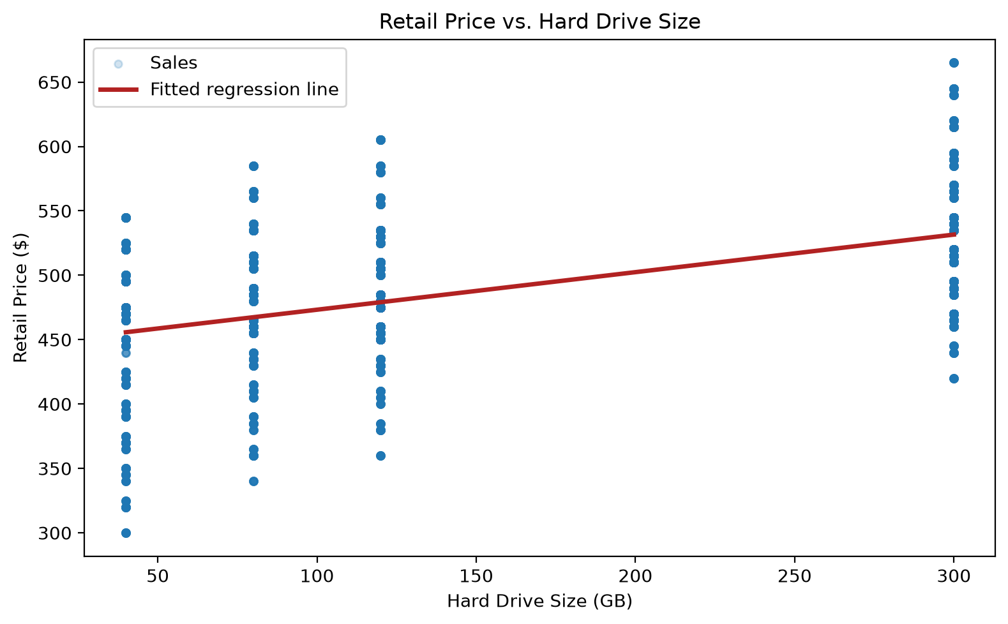
Figure 1. Retail price increases with storage, but wide vertical dispersion shows that other specifications matter.
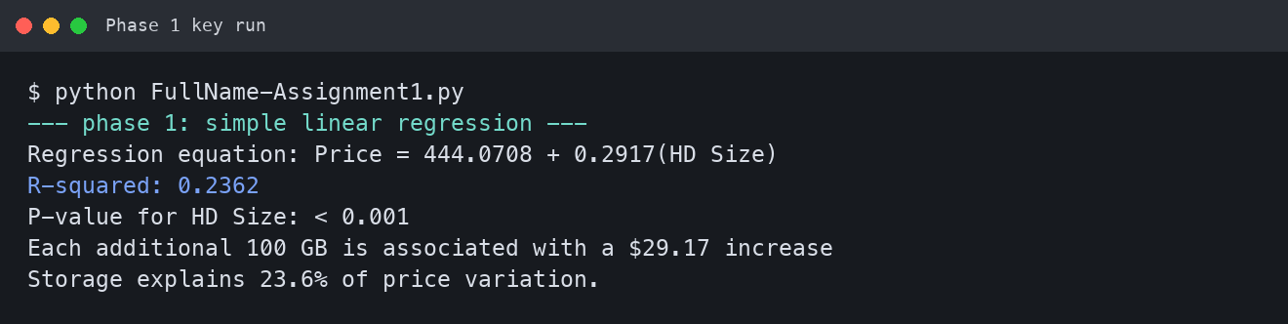
Key run 1. Phase 1 regression results from the completed script.

Phase 2 | Multivariate Optimization
Finding: Adding RAM and battery life improves adjusted R-squared from 0.236 to 0.711. All three coefficients are positive and statistically significant.
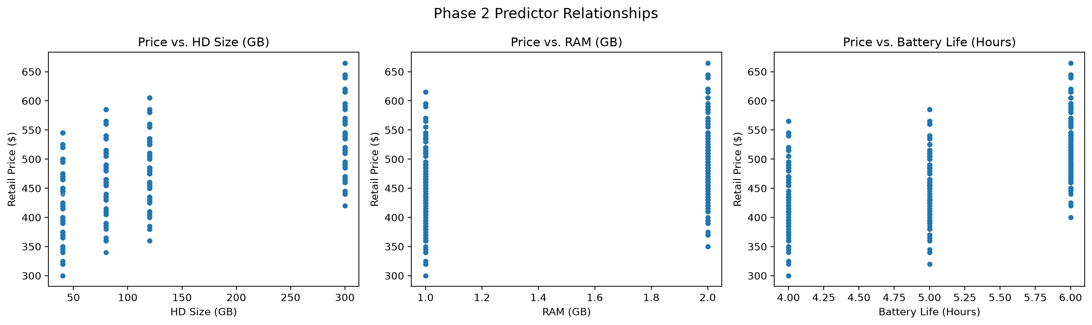
Figure 2. Phase 2 predictor relationships with retail price.
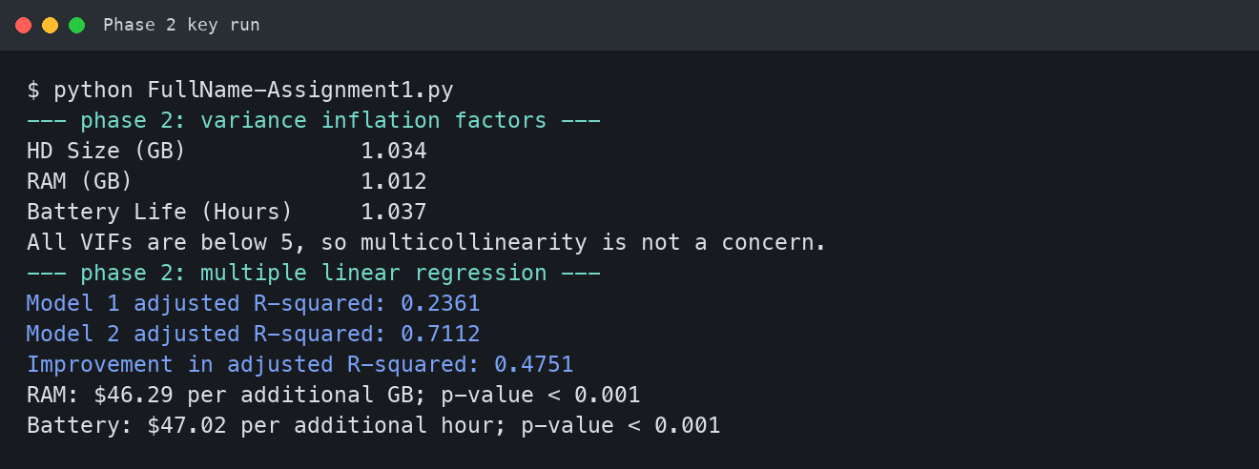
Key run 2. Phase 2 multicollinearity and regression results.
Model stability. VIF values range from 1.012 to 1.037, well below the common concern threshold of 5; no problematic multicollinearity is evident.

Model Diagnostics
Diagnostic conclusion: Model 2 substantially compresses residual error compared with Model 1. The visible bands reflect the dataset's small number of discrete hardware tiers.
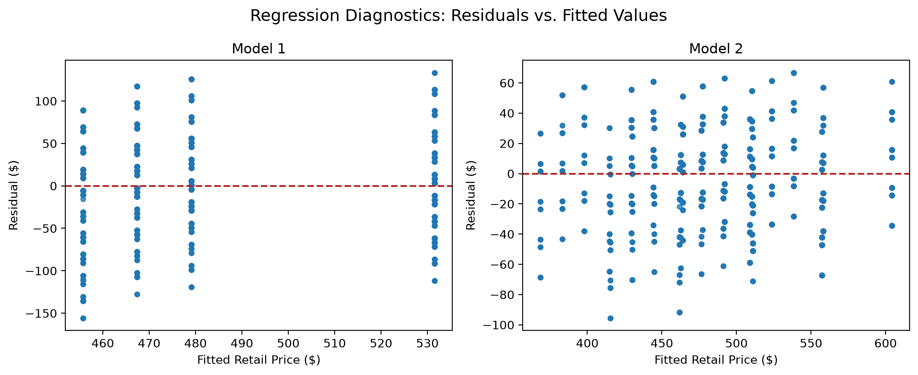
Figure 3. Residuals narrow materially in Model 2, supporting the added predictors.

What the diagnostics mean
Model 1 underfits. Its residuals span a much wider range because storage cannot distinguish the value of memory, battery, processor, and included options.
Model 2 is materially better, not complete. Residual banding remains because the data contain discrete product configurations. That pattern supports adding processor speed and product-option indicators.
Operational implication. Model monitoring should focus on error for unseen configurations, not only in-sample fit. The optimization split therefore holds complete configurations out of training.

Phase 3 | Predictive Deployment
MODEL | POINT FORECAST | 95% PREDICTION INTERVAL
Model 1: storage only | $1,027.45 | $919.91 - $1,134.99
Model 2: storage + RAM + battery | $3,078.57 | $2,987.07 - $3,170.08

Forecast caution: Model 2 is more informative within the training domain, but neither required point forecast is dependable because the request requires extreme extrapolation.
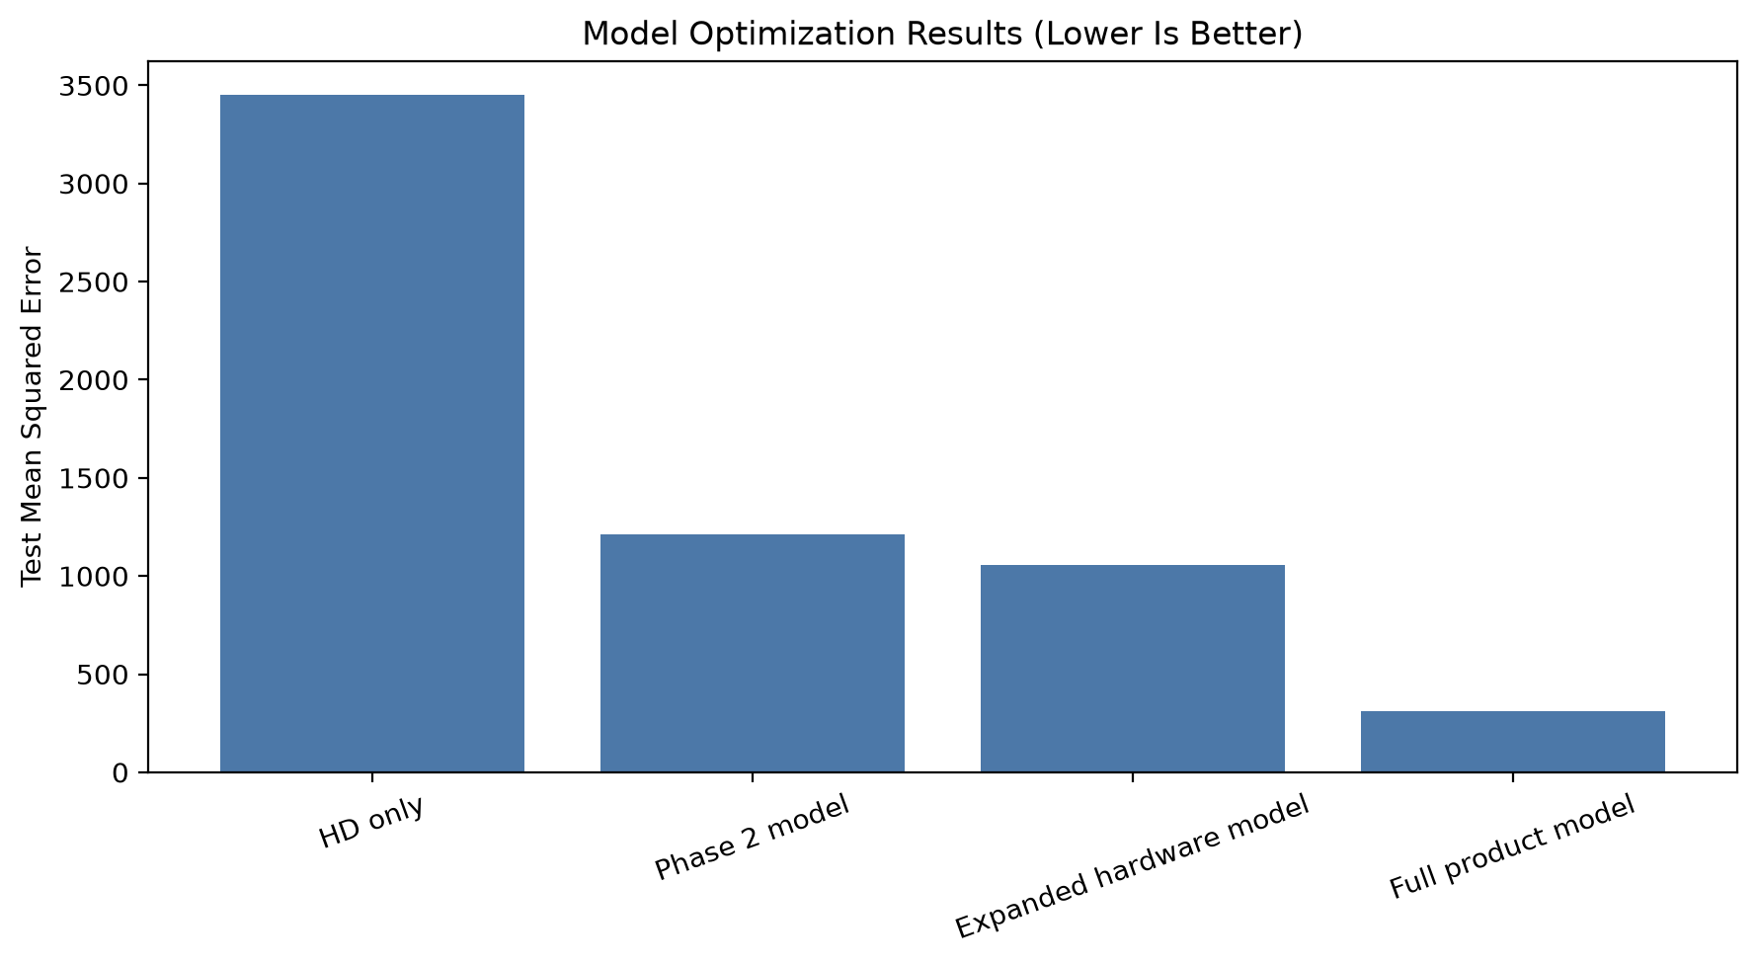
Figure 4. The full product model yields the lowest test MSE on held-out configurations.
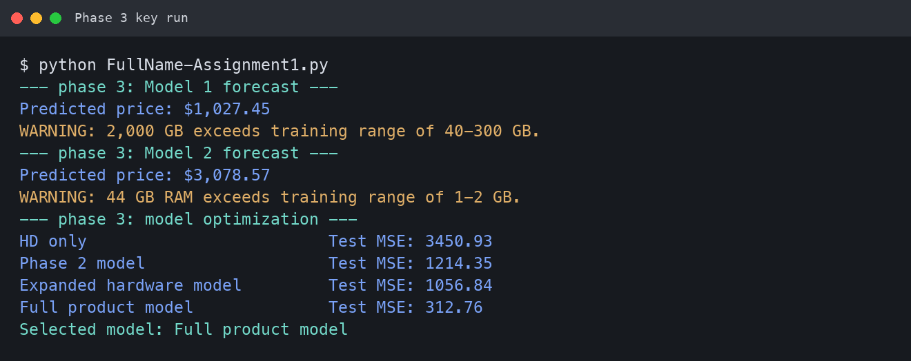
Key run 3. Forecasts, range warnings, and optimization results.
Recommendation. Use the full product model for historically comparable configurations. Before pricing modern high-capacity laptops, collect current observations covering the intended storage and RAM ranges and retrain the model.
Source: LaptopSalesJanuary2008.csv and FullName-Assignment1.py; results reproduced from the verified script run.

